Feasibility Analysis

We are making an application called Face-polygon, for that we had conducted a survey in our (NIIT UNIVERSITY) college. We got 115 responses from the students and even suggestions about the applications.

**Response for the first question**:

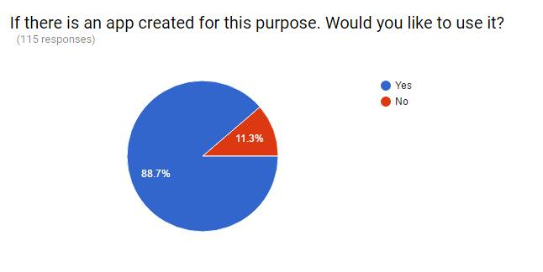

**Response for the second question**:  
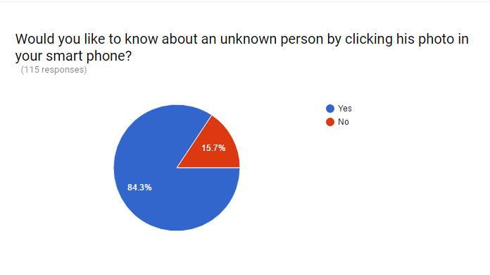

Here we got few suggestions about our applications, which are given by the Niit students.

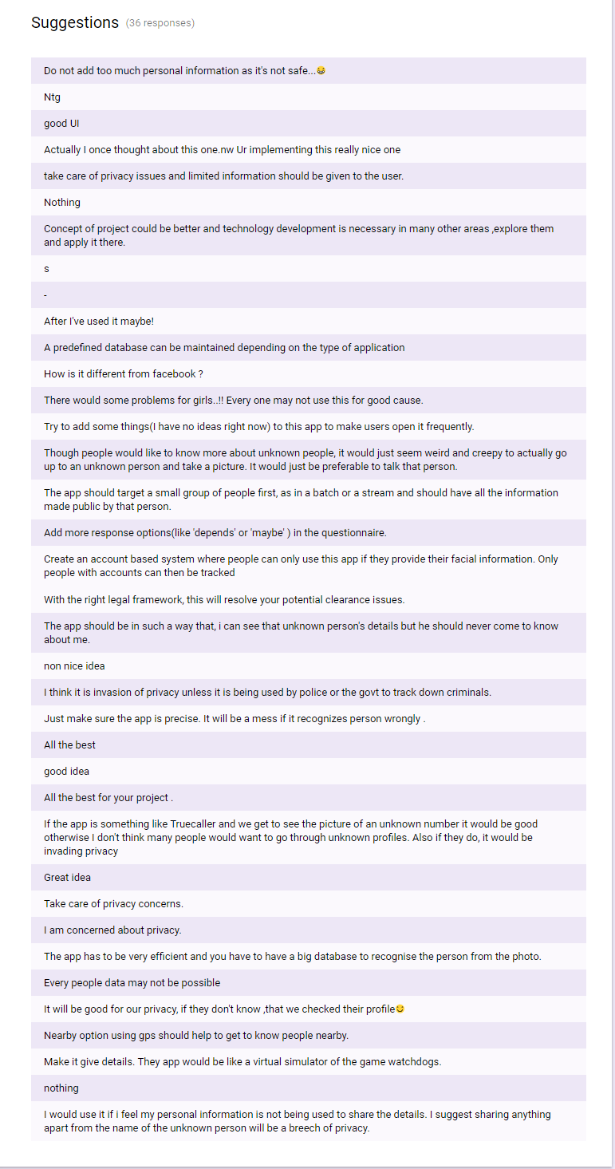

**Conclusion:** The suggestions given by the students is that ,the app which we are making shuold be secure such that no would use it in a bad way. **(**No one can get his/her details to others until they accept there request.**)**